**Guvi ZenClass DB**

// Creating db as class inside class creating collections

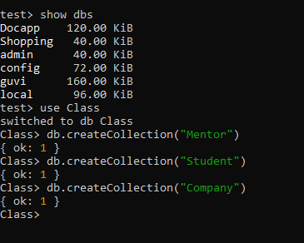

// Adding Students in Student collection

db.Student.insertMany([{object 1},{object 2},{object 3}])

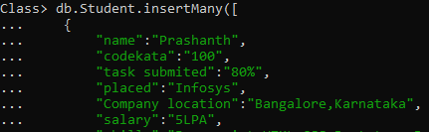

db.Student.find()

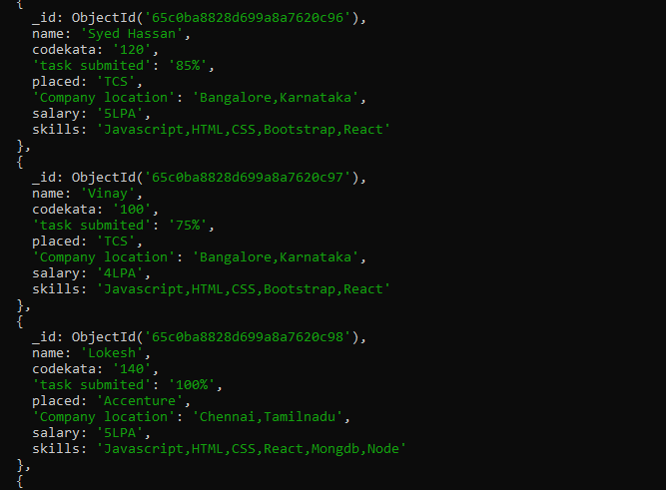

//Mentors table, adding Mentors db.Mentor.insertMany([{object 1},{object 2},{object 3}]),to show added mentors

db.Mentor.find()

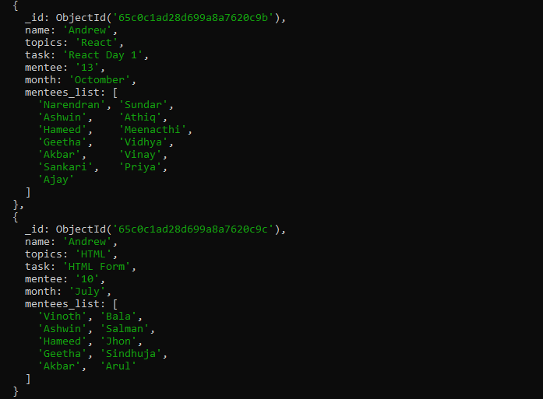

//To find the task or topic db.mentor.find({task:React Day 1})

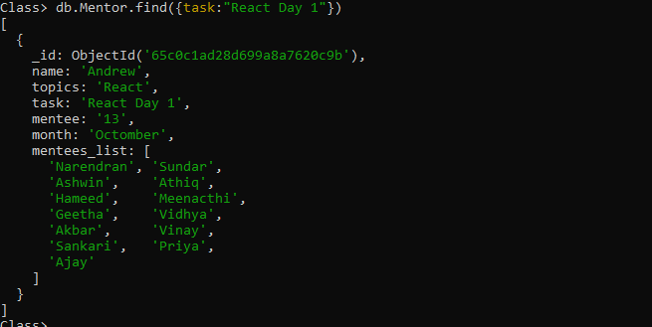

//To add data inside company .db.company.insertMany([ { field 1},{ field 2},{ field 3}])

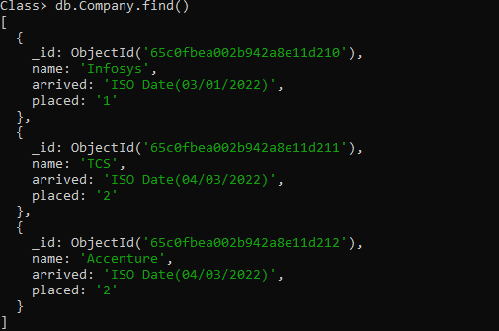

// To find the companies which have arrived from date 01/01/2022

db.Company.find({arrived:{$gt:”date”}})

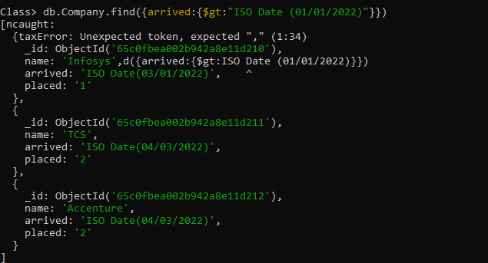

//To find data of interview done between Jan to March

db.Company.find({arrived:{$gte:true,$lte:true}})

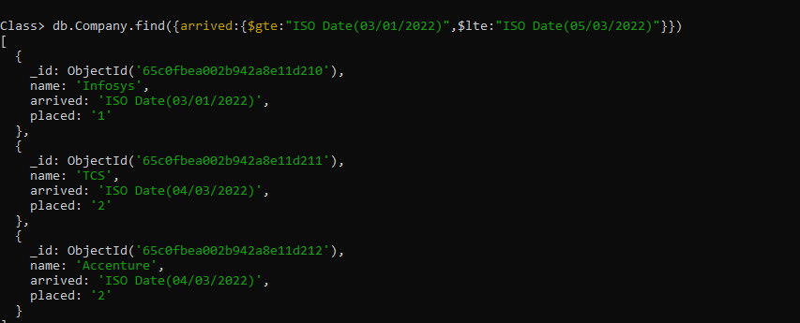

//To find student placed in TCS

db.Student.find({placed:”TCS”})

